Patient Name:
TRUE MEDICAL IMAGING
Chart Number:

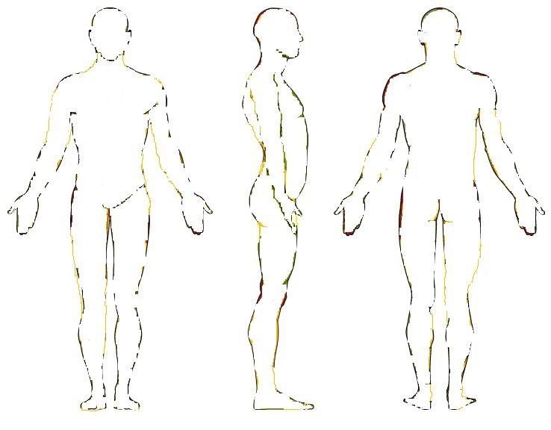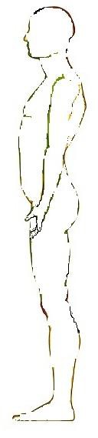
Front Right-Side Back Left-Side
Use the appropriate symbol to show point of pain

Ache | AAAA | Pins and Needles | OOOO
Burning | XXXX | Stabbing | ///////
Numbness |  | Weakness | WWW

How did injury/pain
occur?_

_

Where are you hurting? _

_

How long have these symptoms been present? __

What is your pain level on a scale of a 1-10? (10 being the worst 1 being the least)? _ Please check one: Getting Better __Getting Worse _Staying Constant Intermittent
Have any surgeries or treatment been preformed for the current problem? _ If so, when? __

Tech Notes: _

_

_ _
Signature Date

_ _
Technologist Signature Date

100% Veteran Owned and Operated R 052216

